Design and Fabrication of Suspension System for Formula Student Style Race Car

Head: - Paarth Kumar
Member 1: - Garima
Member 2: - Neel Kedia
Member 3: - Bhaskar


Department of Mechanical Engineering Indian Institute of Technology Guwahati Guwahati-781039, Assam, India
August-2024

Contents
Acknowledgment 2
ABSTRACT 2
Results/Results and Discussion) 2
Chapter 1: Introduction 7
1.1 Motivation 7
1.2 Objectives 7
1.3 Outline of the project 7
1.3.1 Selection of Suspension Type​ 7
1.3.2 Selection of wheels. ​ 7
1.3.3 Establish the vehicle’s dimensions – wheelbase and track width(s); ​ 7
1.3.4 Set up suspension parameters. ​ 7
1.3.5 Model the suspension geometry.​ 7
1.3.6 Components Design 7
Chapter 2: Selection of Suspension​, trackwidth, and wheelbase 8
2.1 Introduction 8
2.2 Selection of Suspension Type 8
2.3 Selection of Wheelbase 8
2.4 Selection of Trackwidth 8
2.5 Tire selection 9
2.5.1 Tractive performance capabilities of tire 9
Chapter 3: 2d Sketching and Kinematic Analysis 11
3.1 Introduction 11
3.2 Setting up Suspension Parameters 11
3.3 Front Suspension 13
3.3.1 2D sketch 13
3.3.2 Lotus analysis 13
3.3.3 Hard-points selection 15
3.3.4 Rocker Motion Ratio 15
3.3.5 ARB Motion Ratio 17
3.4 Rear Suspension 18
3.4.1 2D sketch 18
3.4.2 Lotus analysis 18
3.4.3 Hard-points selection 19
3.4.4 Rocker Motion Ratio 19
3.4.5 ARB Motion Ratio 20
Chapter 5: Spring-damper system 21
5.1 Introduction 21
5.2 Spring-damper system 21
5.2.1 Design Overview 21
5.2.2 Combined Vertical and Lateral Analysis (Ride and Roll) 21
5.2 ARB design & Springs Selection 27
5.2.1 Motion Ratio 27
5.2.1 Ride & Roll Analysis 27
5.2.2 Rear ARB design 27
6. Spring Motion Testing/Analysis 28
6.1 Chapter Introduction 28
6.2 Heat Sink Design 28
6.3 Chapter Conclusion 28
Chapter 7: Force Calculations on Suspension Links 29
7.1 Introduction 29
7.2 Forces on the tire contact patch 29
7.3 The Matrix method: 31
7.4 Results 32
Chapter 4: Results and Discussion 33
5.1 Introduction 34
5.2 Conclusion 34
6. Future Work 35
Bibliography 35
Checklist 36

Chapter 1: Introduction

1.1 Motivation

1.2 Objectives

1.3 Outline of the project

1.3.1 Selection of Suspension Type​

1.3.2 Selection of wheels. ​

1.3.3 Establish the vehicle’s dimensions – wheelbase and track width(s); ​

1.3.4 Set up suspension parameters. ​

1.3.5 Model the suspension geometry.​
->Hard points sketching​
-> Kinematic analysis in lotus.​

1.3.6 Components Design

Chapter 2: Selection of Suspension​, trackwidth, and wheelbase

2.1 Introduction
The purpose of the suspension is to make the job easier for the tires and give a predictable behavior so that the driver can control the car. The suspension is designed to maintain maximum tire contact with the ground, enhancing the car's stability and allowing the tires to perform at full capacity. Our system employs a Double Wishbone design, incorporating Wishbones, Rockers, Springs, Dampers, Anti-roll bar, and Pushrod in front and rear suspensions. Designing a suspension involves balancing various factors that influence its behavior, and a lot of these factors also interacts in one way or another. Therefore much work is put into making a compromise that will function well in all the driving events at the competition. The factors considered in this design process are outlined below.

2.2 Selection of Suspension Type
We opted for a Double Wishbone suspension design for both the front and rear suspensions due to its versatility as a four-bar linkage. This configuration allows for controlled wheel travel, enabling us to minimize caster changes while optimizing the linkage for the desired camber change.

2.3 Selection of Wheelbase
According to the rulebook, the wheelbase must be a minimum of 1525 mm. To ensure the car remains as compact as possible while accommodating all necessary components, we have set the wheelbase at 1590 mm.

2.4 Selection of Trackwidth
During the tilt test, where the car is tilted 60 degrees sideways, it must not topple, and the normal reaction force at any wheel contact point must not reach zero.
With a car mass of 320 kg and a center of gravity height of 315 mm, we calculated a minimum track width of 1080 mm to meet this requirement.
A wider track width helps reduce lateral load transfer, providing more grip during cornering,

Lateral load transfer = $\frac{A_{y}*M*g*h}{t}$

Where, $A_{y}$= lateral acceleration,
M = mass of car,
g = acceleration due to gravity,
h = height of center of gravity,
t = trackwidth,

while a narrower track width allows for greater turning with less steering angle.
Below is a sample calculation to illustrate this point:
Given a constant wheelbase (l) of 1700 mm and a turning radius (r) of 4500 mm, the steering angle is calculated for two different track widths (t): 1250 mm and 1350 mm, for comparison.

$δ$ = $\frac{l}{r-( t/2)}$ = $\frac{1700}{4500-({1250}/2)}$ = 0.439 rad = 25.14$°$
$δ$ = $\frac{l}{r-( t/2)}$ = $\frac{1700}{4500-({1350}/2)}$ = 0.444 rad = 25.46$°$

Through research, we determined that the optimal track width to wheelbase ratio should be around 0.75-0.8.
However, a larger track width can narrow the A-arm angle, leading to increased longitudinal forces on the A-arm.
Considering these factors, we have set the front and rear track widths to 1250 mm and 1200 mm, respectively, balancing the benefits and drawbacks.

2.5 Tire selection
- The primary consideration is to reduce rotating inertia, which leads to choosing smaller hubs, knuckles, rims, and brake discs to minimize corner weight.

- Larger tires offer reduced slip during acceleration and braking, increasing grip at the same torque levels. However, with our 13" Hoosier tires, rims, and associated weight, we require nearly 300 Nm of torque at the wheels to induce slipping—something our KTM 390 engine is not capable of delivering. Larger tires are often preferred because they provide more space for wheel assembly and allow greater flexibility in adjusting steering and suspension hard points.

- Shifting to smaller tires and wheels will reduce both, as component sizes will also decrease significantly. Thus, a decision was made to move from 13’’ wheels to 10’’ wheels.

- The tires were chosen to be Hoosier R25B 18.0x6.0-10.0. with O.D 18 inches, I.D 10 inches and a tire thickness of 6.2 inches. The wheels were chosen to be Braid Ltd. Spain’s sturace wheels.

- This was due to lower cost as compared to other manufacturers, customizability of product, and access to a deep dish wheel, allowing us to push the upright farther out in consideration of better kinematic control.

2.5.1 Tractive performance capabilities of tire
Tire performance parameters are divided into three categories based on typical 'Tire Model' equations:
- Compound-Based: Involves parameters like μx and μy​, which determine the maximum performance of the tires.
- Geometry-Based: Involves parameters such as camber stiffness, which are influenced by factors like aspect ratio, lateral, and vertical stiffness of the tire.
- Runtime-Based: Includes normal reactions, dynamic camber, steering angle, etc., which influence slip angle/slip ratio at the tires, determining the Fx/Fy levels.

By fitting data to a model, we can generate coefficients that predict tire behavior under different loading conditions. The goal of testing is to identify these practical, real-time load cases.
Since we lacked sufficient data to build a comprehensive model, we created a rudimentary. We had information on μx​ and μy from previous tires. Additionally, Avon Tires provides some Formula Student tire data online, allowing us to estimate critical points on the curve, such as the peak Fx and Fy, cornering stiffness, camber stiffness, and spring rate. Using this information, we were able to create steady-state cornering parameters and yaw-moment diagrams accordingly.
The model we used assumed a linear relationship between slip angle and Fy within a certain range around 0 degrees, and for angles greater than 3.5 degrees, we used 0.7 Fymax. While this approximation may not be entirely accurate, it provided a working model with about 15% error in Fy under peak loading or high camber (5 degrees) conditions, which was acceptable for our purposes.
Based on the desired behavior of mild understeer in a rear-weight-biased vehicle, we modeled different suspension mechanisms to optimize wheel travel, peak lateral acceleration (Fz), and maximize Fy at each wheel. A detailed process is outlined in "Race Car Vehicle Dynamics" (RCVD).
For further reference, see:
- Avon Tires Formula Student Technical Data

Chapter 3: 2d Sketching and Kinematic Analysis

3.1 Introduction

3.2 Setting up Suspension Parameters

- Camber gain
One crucial parameter in suspension design is camber gain, which determines how much of the tire remains in contact with the ground during dynamic conditions.
Camber refers to the angle between the plane of the wheel and a vertical line perpendicular to the ground.
(figure below is from the website “come and drive it” (https://www.comeanddriveit.com/suspension/camber-caster-toe))
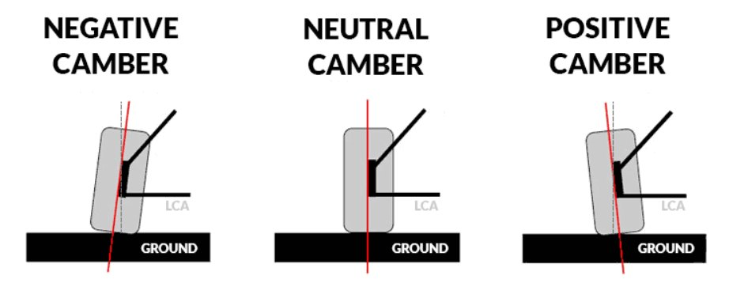
In a double wishbone suspension system, the camber angle of each wheel changes as the car rolls during cornering. While excessive camber change under roll is undesirable, a slight camber adjustment is necessary to enhance grip. Negative camber on the front tires is generally recommended to improve cornering grip by increasing lateral force; however, it should be controlled to avoid excessive wear on the inside contact patch. Typically, the front camber value should be more negative than the rear to optimize handling. The rear camber should remain close to zero to maximize the contact patch and provide better grip. The objective is to design a geometry that minimizes camber gain under roll, balancing performance and tire wear.

- Scrub radius, KPI, Caster angle
Scrub radius significantly influences overall vehicle behavior. During cornering, variations in normal reactions on the tires cause different amounts of rubber to contact the road. Under higher scrub radius conditions, this change in contact patch alters the slip angle, which can lead to driver disturbances and potential understeer.

In a straight line, a higher scrub radius can affect vehicle yaw stability during braking. If brake force distribution is uneven, a high scrub radius can generate significant steering forces, making it challenging for the driver to maintain control.

The kingpin axis inclination assists in steering by allowing the driver to generate a moment about the tire contact patch, helping to overcome the restoring moment. In racing vehicles, this inclination typically ranges from 5 to 7 degrees. Both scrub radius and kingpin axis inclination determine the axis of the ball joints, with the clearance of the lower heim joint from the brake disc being a critical constraint.

By opting for a deep dish wheel with a 15mm offset, we established a front wheel inclination of 7 degrees and a scrub radius of 30mm. Similarly, for the rear wheels, we achieved an inclination of 7 degrees and a scrub radius of 25mm.

Decisions on mechanical trail were guided by the need to maintain aligning torque. At peak lateral force, the aligning torque decreases, causing the driver to lose some steering feel. At this point, the added mechanical trail becomes the primary source of steering feedback. Based on calculations, the mechanical trail was determined to range between 16 and 24mm, which informed the decision to set the caster angle to 3.8 degrees.

- Roll centre
The roll center is the force coupling point of the car, serving as the pivot around which moments act.

High roll centre: A higher roll center reduces body roll (since the moment from centrifugal force acting on the center of gravity is smaller), but it also introduces more jacking forces, which can lift the center of gravity and affect vehicle stability.
Low roll centre: A lower roll center is desirable to minimize jacking forces on the chassis and suspension. However, achieving this often requires a compromise between roll camber gain and roll center height.

To optimize the roll center:

Front Roll Center: Aim to keep the front roll center around 30mm above the ground. There's no definitive method to quantify this, so it requires iterative testing to determine the best setup.
Roll Center Movement: Ensure that the front and rear roll center movements are equal and in the same direction. Additionally, the roll center height should remain above the ground during movement.
Lateral Load Transfer: Roll center height affects how much lateral load is transferred through the suspension versus how much is handled by the springs and anti-roll bar. A higher roll center enables faster load transfer during cornering, but it can compromise stability due to increased jacking forces, which raise the center of gravity and may lead to potential overturning in fast cornering situations.

For the suspension setup:

Front Suspension: The jacking line was set at 3 degrees, with the static instant center (IC) placed at 1800mm. This was determined using Excel sheet calculations to find the optimal static IC location, beyond which no significant camber gain was observed. In a symmetric vehicle, the static roll center is located on the vehicle centerline at a height of approximately 31mm.
Rear Suspension: The rear jacking line was established at 5.5 degrees to account for the vertical difference between the front and rear suspensions. The rear wishbones are designed to be nearly parallel, resulting in minimal camber change during wheel and roll travel.

3.3 Front Suspension

3.3.1 2D sketch
Based on the suspension parameters outlined above, a 2D sketch was created to visualize and optimize the suspension geometry.
This 2D sketch served as a foundation for further analysis and adjustments in the suspension design process.
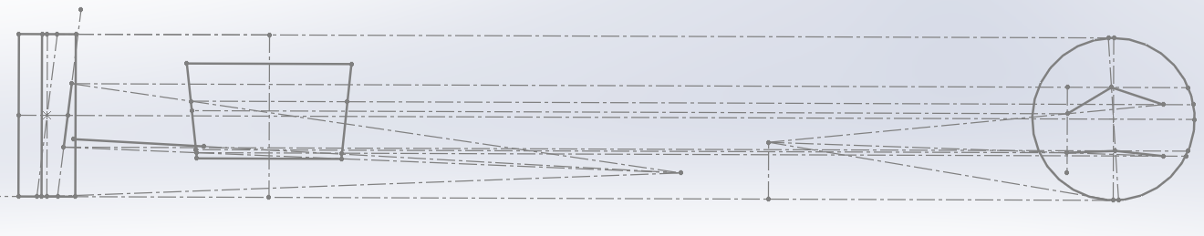

Parameter | Value
FVSA | 1670.43
Roll Centre height | 27.19
SVSA | 970
Scrub Radius | 30
Caster Angle | 3.8
Kingpin Angle | 7

3.3.2 Lotus analysis

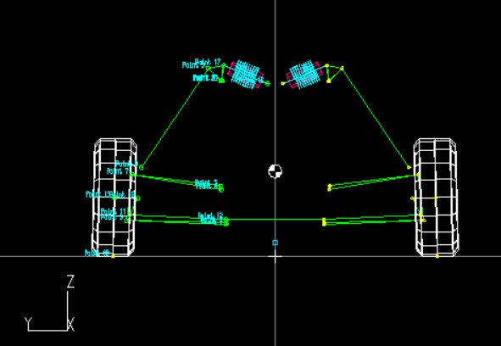
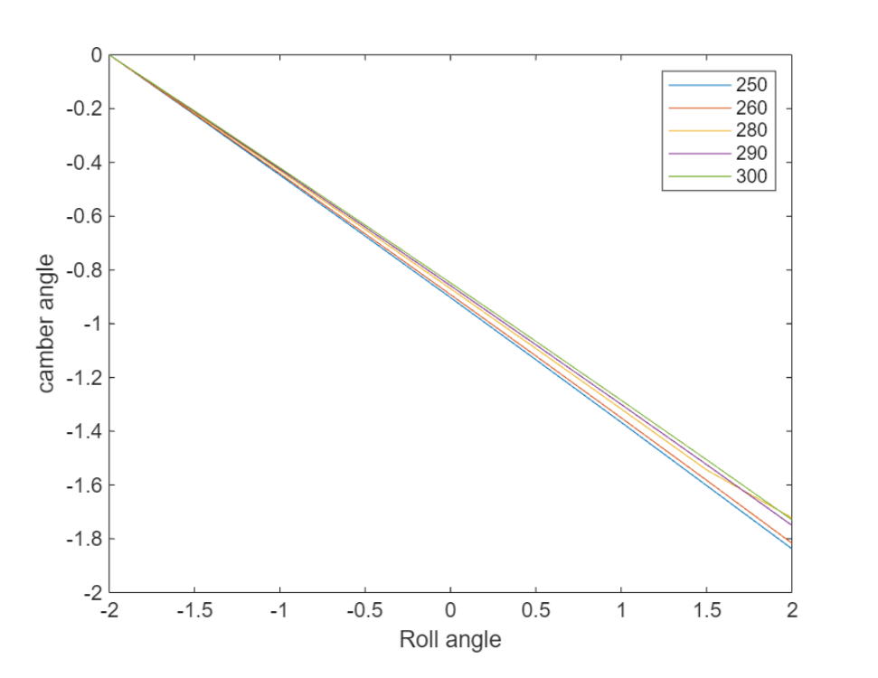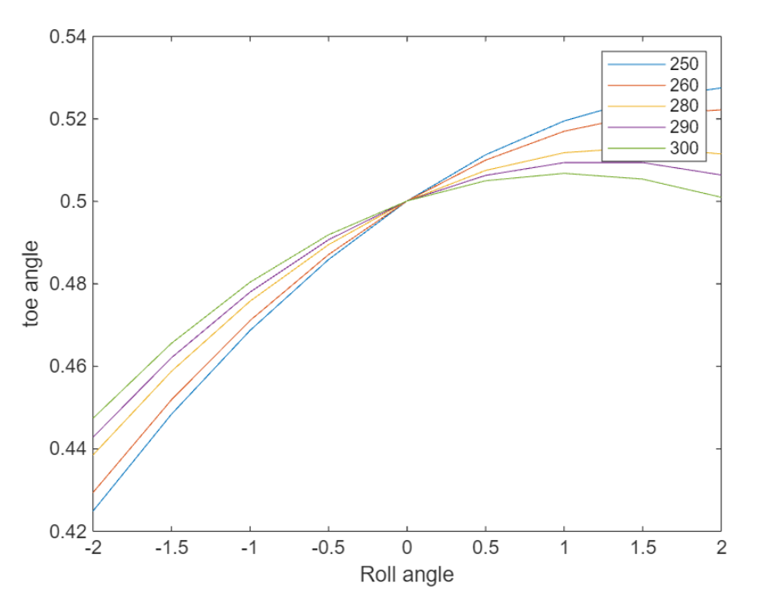

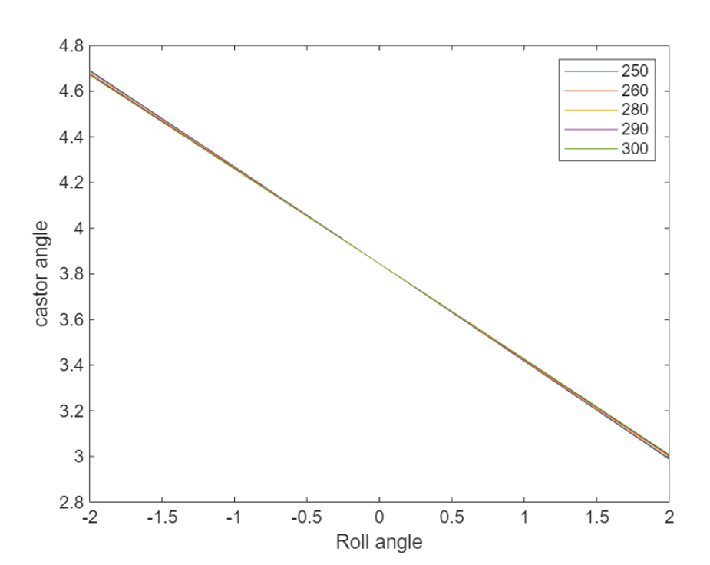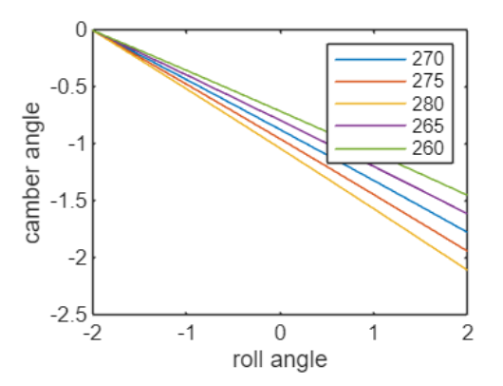

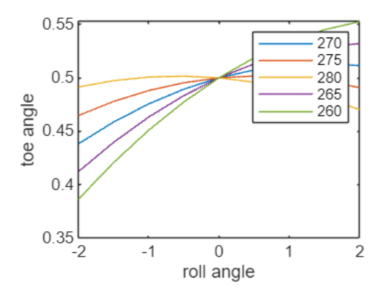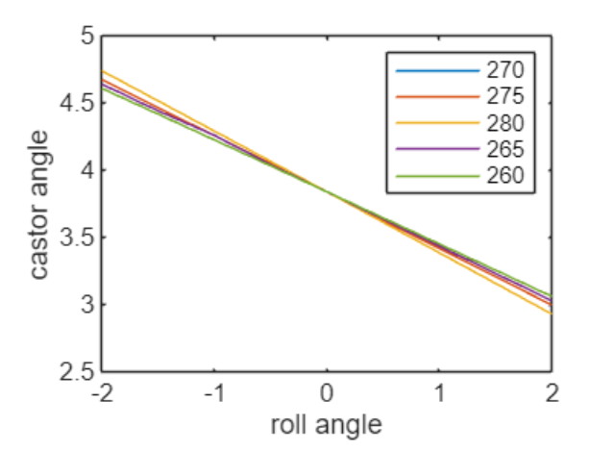

3.3.3 Hard-points selection

Point | x-coordinate | y-coordinate | z-coordinate
Tie rod inboard | 80 | 90 | 142.75
LCAF inboard | 140 | 230 | 125
LCAR inboard | -130 | 230.76 | 133.51
UCAF inboard | 140 | 243 | 270
UCAR inboard | -130 | 240.6 | 243.24
Push rod inboard | -5.93 | 292.65 | 657.8
Tie rod outboard | 70.65 | 565 | 161
LCA outboard | 5.93 | 577.9 | 139.27
UCA outboard | -5.93 | 555.96 | 317.93
Pushrod outboard | -5.93 | 515.96 | 357.93

3.3.4 Rocker Motion Ratio

To calculate the motion ratio and spring travel for a double wishbone pushrod actuated suspension system, we understood the relationship between wheel travel and spring travel.
The motion ratio (MR) is the ratio between the wheel travel and the spring travel.
It's given by:
MR=Spring Travel/Wheel travel

Comparison of direct actuation with pushrod actuated suspension systems lead to choice of latter for
(i)there was prior knowledge of this set-up having been used on the previous system and
(ii) rockers could be easily used to achieve decreasing spring travel with increasing wheel travel.

The outboard vertical position of the pushrod mount was based on the diameter of the rod-end bearing, and mount was centrally situated along the longitudinal axis of the vehicle. And the position, along the lateral axis of the vehicle, was also based on the diameter of the rod-end and the approximate position of the wheel assembly. The aim was to keep this point as close as possible to the lower control arm ball joint while maintaining no interference between the wheel assembly and the pushrod through-out its range of motion.
2D cad is then used to simulate the movement of the assembly through bumps. This was simulated for progressive wheel travel of 5 mm starting from zero and ending on 30 mm wheel travel. The sketch of the effect of 5 mm wheel travel progressions on the push-rod and rocker is shown in below figure respectively. Table comprises the change in Motion Ratio with y.
The main objective for both was to achieve an increasing motion ratio throughout the wheel travel, which means that the amount of net spring travel decreases with increase in wheel travel. This would increase the dynamic stability of camber with increasing wheel travel.
The maximum compression in the spring was calculated. The consequent wheel travel for this maximum compression is then deduced.
Since the spring-damper setup alone couldn't achieve the desired roll resistance, an anti-roll bar was installed.

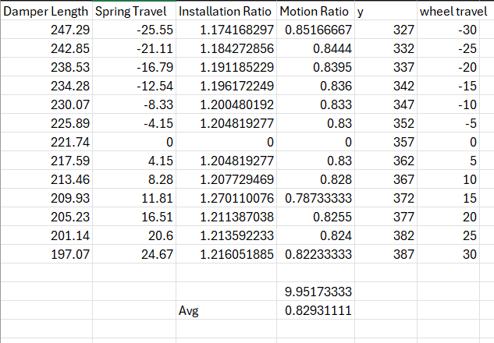

Front rocker

front rocker
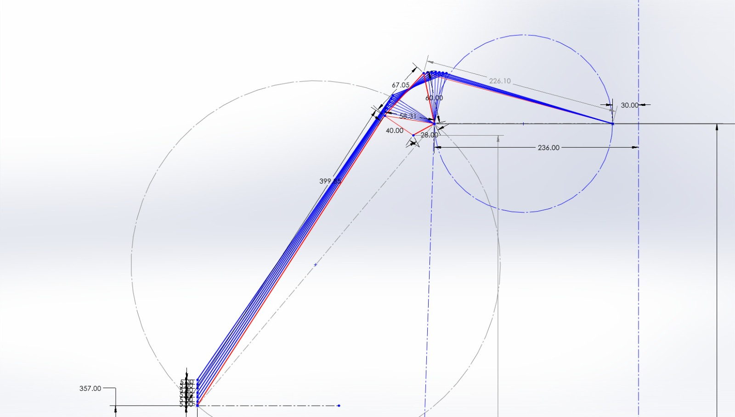

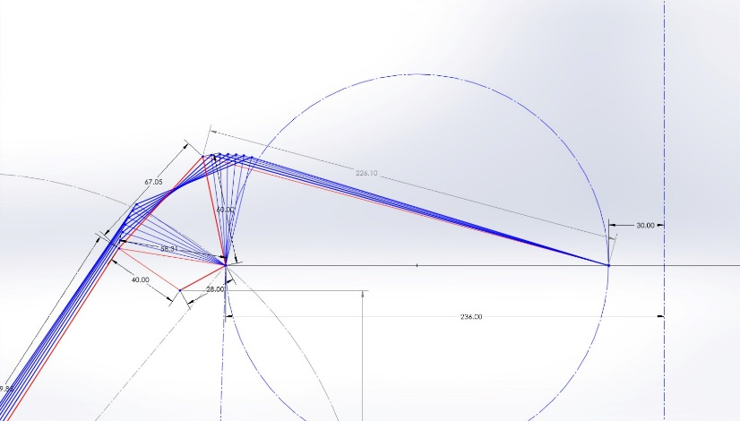

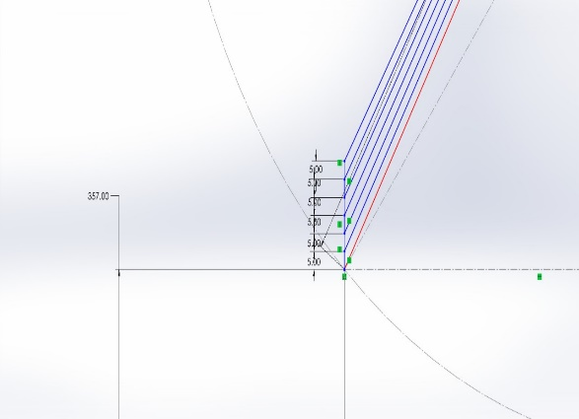

3.3.5 ARB Motion Ratio

The position of the ARB mounting point will decide the motion ratio which will be used to calculate the ARB roll stiffness.
By carefully selecting the ARB mounting point on the rocker within the calculated constraints, we achieved the desired roll stiffness and wheel travel control balance, optimizing the vehicle's handling characteristics.
We have taken three points to mount the ARB push rod to vary our motion ratio and based on ARB lever length obtained different motion ratio.
Roll angle =1.92
The vehicle roll stiffness must be adjustable from ½ * k_{roll, vehicle}
to 2 * k_{roll, vehicle}, to be able to adjust the understeer and oversteer behavior of the car over
a wide enough range. The anti-roll system will therefore have to be adjustable from
(½)^{1/2} k_{roll, vehicle} to 2 * k_{roll, vehicle}, to account for the roll motion ratio.

$${Arb}_{MR}=\frac{ARB Twist Angle}{Roll Angle}$$

ARB Motion Ratio | Arm Length | ARB Angle
2.49 | 141.48 | 4.78
3.526 | 100 | 6.7709
4.98 | 70.91 | 9.57

front arb

3.4 Rear Suspension

3.4.1 2D sketch
Based on the suspension parameters outlined above, a 2D sketch was created to visualize and optimize the suspension geometry.
This 2D sketch served as a foundation for further analysis and adjustments in the suspension design process.

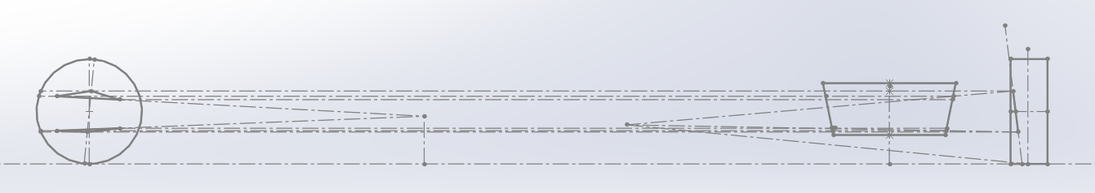

Parameter | Value
FVSA | 1736.69
Roll Centre height | 58.7
SVSA | 1450
Scrub Radius | 25
Caster Angle | -5.5
Kingpin Angle | 7

3.4.2 Lotus analysis

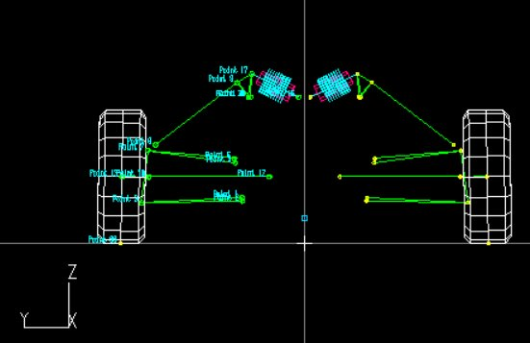

3.4.3 Hard-points selection

Point | x-coordinate | y-coordinate | z-coordinate
LCAF inboard | 130 | 248.14 | 155.70
LCAR inboard | -140 | 246 | 145
UCAF inboard | 130 | 273.05 | 280.23
UCAR inboard | -140 | 276 | 295
Push rod inboard | -5.93 | 331.53 | 529.24
LCA outboard | -8.6 | 557.9 | 139.27
UCA outboard | 8.6 | 535.96 | 317.93
Pushrod outboard | -5.93 | 495.96 | 357.93

3.4.4 Rocker Motion Ratio

To calculate the motion ratio and spring travel for a double wishbone pushrod actuated suspension system, we understood the relationship between wheel travel and spring travel.
The motion ratio (MR) is the ratio between the wheel travel and the spring travel.
It's given by:
MR=Spring Travel/Wheel travel

Comparison of direct actuation with pushrod actuated suspension systems lead to choice of latter for
(i)there was prior knowledge of this set-up having been used on the previous system and
(ii) rockers could be easily used to achieve decreasing spring travel with increasing wheel travel.

The outboard vertical position of the pushrod mount was based on the diameter of the rod-end bearing, and mount was centrally situated along the longitudinal axis of the vehicle. And the position, along the lateral axis of the vehicle, was also based on the diameter of the rod-end and the approximate position of the wheel assembly. The aim was to keep this point as close as possible to the lower control arm ball joint while maintaining no interference between the wheel assembly and the pushrod through-out its range of motion.
2D cad is then used to simulate the movement of the assembly through bumps. This was simulated for progressive wheel travel of 5 mm starting from zero and ending on 30 mm wheel travel. The sketch of the effect of 5 mm wheel travel progressions on the push-rod and rocker is shown in below figure respectively. Table comprises the change in Motion Ratio with y.
The main objective for both was to achieve an increasing motion ratio throughout the wheel travel, which means that the amount of net spring travel decreases with increase in wheel travel. This would increase the dynamic stability of camber with increasing wheel travel.
The maximum compression in the spring was calculated. The consequent wheel travel for this maximum compression is then deduced.
Since the spring-damper setup alone couldn't achieve the desired roll resistance, an anti-roll bar was installed.

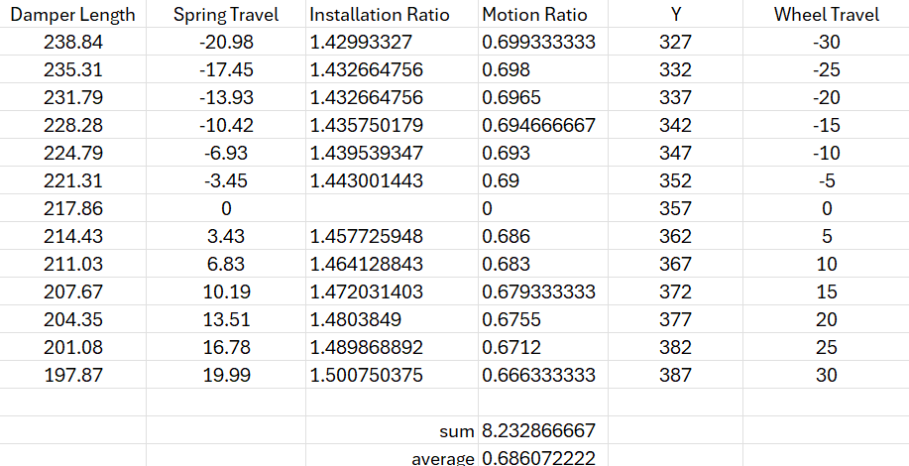

Rear rocker

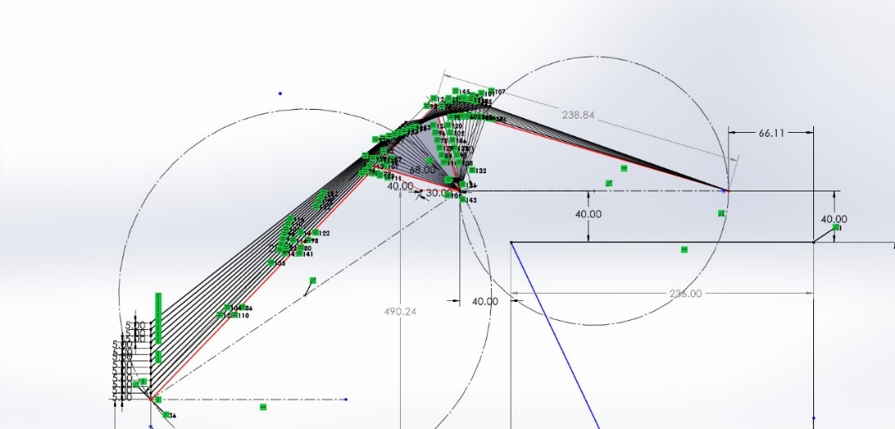

3.4.5 ARB Motion Ratio

The position of the ARB mounting point will decide the motion ratio which will be used to calculate the ARB roll stiffness.
By carefully selecting the ARB mounting point on the rocker within the calculated constraints, we achieved the desired roll stiffness and wheel travel control balance, optimizing the vehicle's handling characteristics.
We have taken three points to mount the ARB push rod to vary our motion ratio and based on ARB lever length obtained different motion ratio.
Roll angle =1.92
The vehicle roll stiffness must be adjustable from ½ * k_{roll, vehicle}
to 2 * k_{roll, vehicle}, to be able to adjust the understeer and oversteer behavior of the car over
a wide enough range. The anti-roll system will therefore have to be adjustable from
(½)^{1/2} k_{roll, vehicle} to 2 * k_{roll, vehicle}, to account for the roll motion ratio.

$${Arb}_{MR}=\frac{ARB Twist Angle}{Roll Angle}$$

ARB Motion Ratio | Arm Length | ARB Angle
3.79 | 60.34 | 7.29
2.684 | 85.28 | 5.153
1.898 | 120.52 | 3.644

rear arb

Chapter 5: Spring-damper system

5.1 Introduction
This chapter focuses on the mechanical design and fabrication of cell packaging and the test rig. The Setup should be rigid, and easy to assemble and disassemble. The setup includes the Electronic Control Unit, Heating Element, and cell assembly. We will also discuss the goal and parameters involved in the design and Development of the whole Setup.

5.2 Spring-damper system

5.2.1 Design Overview

Assembly Photo

5.2.2 Combined Vertical and Lateral Analysis (Ride and Roll)
Goals: -​
1. The front ride rate for low downforce fsae vehicle lies between 1.5 Hz to 2.5 Hz and the rear is 0.2-0.4 unit high.​
2. Being aware of the situation of FSAE tracks, a Stiff roll gradient should be chosen. Therefore, a roll gradient​ between 1.2-1.8 deg/g will be a better decision. ​
3. The ride frequency is above 2 Hz, reason being that the driver does strict maneuvering on the race track.​ Thus if the ride is kept soft then the response of the vehicle is slow to the input causing a lag, thus affecting ​the ride and handling of the car.

Notation | Parameter | Value | Unit
M | Total Mass | 320 | kg
Mf | Front Axle Mass |  | kg
Mr | Rear Axle Mass |  | kg
Musf | Front axle un-sprung mass | 19 | kg
Musr | Rear axle un-sprung mass | 23.5 | kg
Msf | Front axle sprung mass |  | kg
Msr | Rear axle sprung mass |  | kg
L | wheelbase
Zrf | Front roll center height | 0.
Zrr | Rear roll center height
h | Height of cg of whole car | 0.315 | m
Rlf | Front tire loaded radius | 0.21717 | m
Rlr | Rear tire loaded radius | 0.21717 | m
r | Target roll gradient | 1.5 | Deg/g
Tf | Front trackwidth | 1.25 | m
Tr | Rear trackwidth | 1.2 | m
Table 1Vehicle mass properties

Target Parameters

Target Roll Gradient(1.5 deg/g)

Ride Frequency
Roll stiffness required

Front Roll Stiffness

Ride frequency

Front ARB roll stiffness
Spring roll stiffness
Ride rate

Wheel Rate

Spring rate

- Roll stiffness Calculation

$h_{s}=\frac{M*h-M_{usf}*Rlf-M_{usr}*Rlr }{M_{s}}$ , where $h_{s}$ is sprung mass cg height
$h_{arm}=h_{s}-(Z_{rf}+\left(Z_{rr}-Z_{rf}\right)*\left(1-as\right)$ %Roll_lever_arm
$M_{phi,L}=h_{arm}*M_{s}*9.81*A_{y}$ % rolling moment lateral comp
$M_{phi,G}=h_{arm}*M_{s}*9.81*phi/180$ % rolling moment gravity comp

% divide by Ay, phi/Ay is r
%M_phi = M_phiL/Ay+M_phiG*r %roll moment per g, unit in Nm/g
M_phi = M_phiL/Ay+h_arm*Ms*9.81*r/180 %roll moment per g, unit in Nm/g
K_phi= (M_phi/r)*(180/pi) %required total roll stiffness/rate, unit in Nm/rad

- Lateral Load Calculation

$$T_{avg}=(T_{r}+T_{f})/2$$
$$W=M*9.81$$
$T_{llt}=W*h*A_{y}/T_{avg}$ , where $T_{llt}$ is total load transfer, unit in N
$L_{tp}=0.48$ , load transfer percent recommended to start with 5% more than total
$F_{lt}=T_{llt}*L_{tp}$ , front load transfer
$R_{lt}=T_{llt}-F_{lt}$ , rear load transfer
$phi=r*A_{y}$ , chassis roll angle
$K_{phi,f}=K_{phi}*L_{tp}$
$K_{phi,r}=K_{phi}-K_{phi,f}$ , rear roll stiffness

After fixing front and rear roll stiffness distribute roll stiffness in springs and anti roll bar

$W_{fo}=M_{f}*9.81/2$ , static weight on front outside tire
$W_{fi}=M_{f}*9.81/2$ static weight on front inside tire
$W_{ro}=M_{r}*9.81/2$ static weight on rear outside tire
$W_{ri}=M_{r}*9.81/2$ static weight on rear inside tire

Allowed wheel travel (t) in m,

$$t=0.045$$
$$K_{rf}=F_{lt}/t$$
$$K_{rr}=R_{lt}/t$$

- Spring Parameters
$f_{f}=\left(\frac{1}{2π}\right)*\sqrt{\frac{2*K_{rf}}{M_{sf}}}$ , front ride frequency (Hz)
$f_{r}=\left(\frac{1}{2π}\right)*\sqrt{\frac{2*K_{rr}}{M_{sr}}}$ , rear ride frequency
$K_{t}=130800$ , tire vertical stiffness
$K_{wf}=K_{rf}*K_{t}/(K_{t}-K_{rf})$ , front wheel center rate
$K_{wf}=K_{rr}*K_{t}/(K_{t}-K_{rr})$ , rear wheel center rate
$$M_{rf}=1.15$$
$$M_{rr}=1.457$$
$$I_{Rf}=1/M_{rf}$$
$$I_{Rr}=1/M_{rr}$$
$$K_{sf}=K_{wf}/{I_{Rf}}^{2}$$
$$K_{sr}=K_{wr}/{I_{Rr}}^{2}$$
$$K_{sf_final}=K_{sf}*(\frac{0.2248}{39.37})$$
$$K_{sr_final}=K_{sr}*(\frac{0.2248}{39.37})$$
$K_{phi,sf}={T_{f}}^{2}*(\frac{K_{rf}}{2})$ , front spring roll rate (Nm/rad)
$K_{phi,sr}={T_{r}}^{2}*(\frac{K_{rr}}{2})$ , rear spring roll rate (Nm/rad)

- ARB Design
$$K_{phi,arbf}=K_{phi,f}-K_{phi,sf}$$
$$K_{phi,arbr}=K_{phi,r}-K_{phi,sr}$$

$${MR}_{f.arb}=3.526$$
$${MR}_{r,arb}=2.684$$
$K_{phi,arbf_final}=K_{phi,arbf}/{{MR}_{f,arb}}^{2}$ , total stiffness of arb required (Nm/rad)
$$K_{phi,arbr_final}=K_{phi,arbr}/{{MR}_{r,arb}}^{2}$$

The push rod is connected to the main rocker. The coil-over damper is mounted to this bell crank on one end and to the re ar frame on the other. The rocker rotates in a bearing holder mounted on top of the bulkhead.
The damper operates most efficiently when compressing or extending along its intended axis. A perpendicular force ensures that the damper works as designed, improving the vehicle's handling and ride comfort.
To minimize lateral forces, design the rocker arm to maintain as close to a 90-degree angle between the pushrod and rocker arm as possible at max bump.
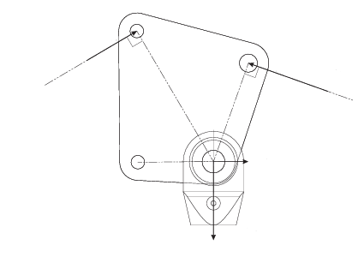
Optimize the pushrod attachment points to control the angle variation during suspension travel, minimizing the impact of bump steer on rocker forces.
The perpendicular force on the rocker at maximum bump steer is maintained because it can introduce additional stresses and potential deformation if not accounted for in the design.
At a 90-degree angle, the mechanical advantage is optimized. The force exerted by the pushrod is fully transmitted to the rocker and then to the damper. There is no component of the force lost in a direction that does not contribute to spring compression.

When the pushrod and damper are perpendicular to the rocker, bending moments on the rocker arm are minimized. This reduces stress concentrations that could lead to deformation or failure of the rocker.
The pivot point of the rocker is positioned so that the 90-degree angle is achieved at the maximum bump. This involved iterative design adjustments, including changing the lengths of the pushrod or rocker arm.
The design was carefully crafted with consideration for the bearings, ensuring proper clearance and conducting stress analysis to minimize the risk of stress accumulation in the rocker arm.
Damper length

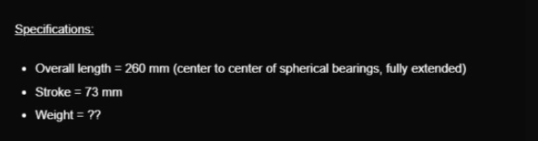

The design ensures that the damper length is approximately 200mm at the static position and remains greater than 187mm at the maximum bump.

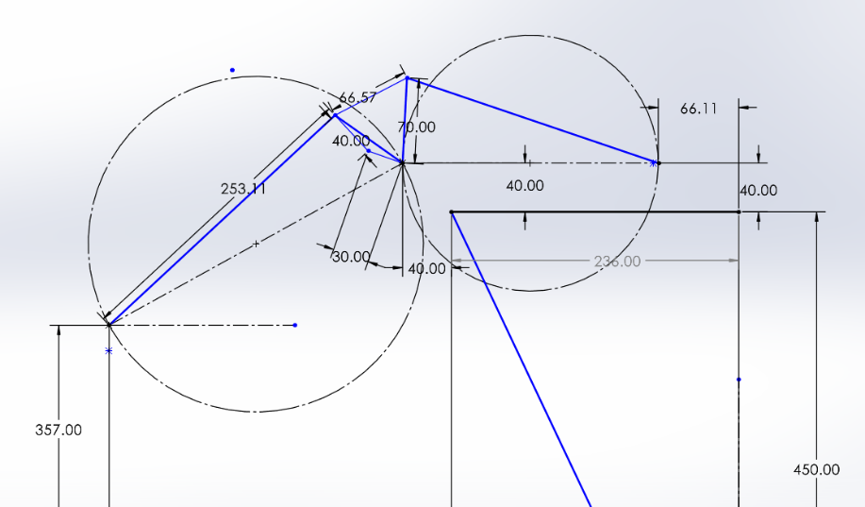

Rear Rocker
static at z=357mm

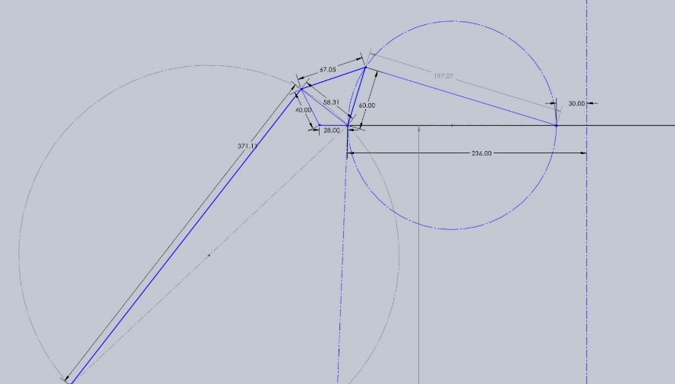

static at z=357mm
Front rocker

5.2 ARB design & Springs Selection
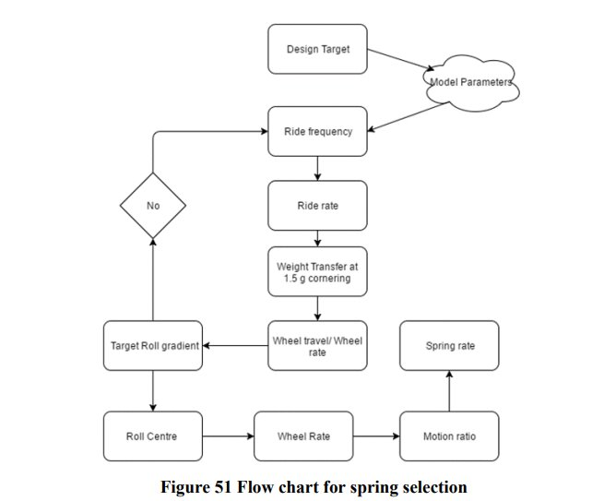

5.2.1 Motion Ratio

5.2.1 Ride & Roll Analysis

5.2.2 Rear ARB design
The rear anti-roll system will make use of a solid torsion bar with levers on each end, just like the front of the car. The vehicle roll stiffness has to be adjustable from $\frac{1}{2}.k_{roll,arb }$to $2.k_{roll,arb }$, to adjust the understeer and oversteer behavior of the car over a wide enough range. The anti-roll system will therefore have to be adjustable from $\sqrt{2}.k_{roll,arb }$ to $\frac{1}{\sqrt{2}}.k_{roll,arb }$ vehicle, to account for the roll motion ratio.

6. Spring Motion Testing/Analysis

6.1 Chapter Introduction

To watch the behavior of the novel electrolyte at different temperature ranges we needed to devise a temperature control unit that would eventually control the heating element. In our case, the Peltier element is used which is a thermoelectric cooling/ heating element. A custom PCB is

6.2 Heat Sink Design

It is known the Peltier element will reject some amount of heat which needs to be dissipated properly through a heat sink in order to proper function of the Peltier element.

6.3 Chapter Conclusion

Chapter 7: Force Calculations on Suspension Links

7.1 Introduction
We need to calculate the forces in the suspension members including the wishbones, the pushrod as well as the tie rod to finalize their specifications (material and dimensions). All the calculations for this process are processed and documented in MATLAB.

7.2 Forces on the tire contact patch
We need to find the forces on each tire at the contact patch in all 3 directions; longitudinal, lateral and vertical; in various cases.

Case 1: Linear acceleration
In this case, there will be load transfer to the rear.
Longitudinal force on one tire:
$$F_{xf}=\frac{\frac{μ*W}{l}*\left(l_{2}+f_{r}*h\right)}{\begin{aligned}2*(1+\frac{μ*h}{l}) \\ \end{aligned}}$$
$$F_{xr}=\frac{\frac{μ*W}{l}*\left(l_{1}-f_{r}*h\right)}{\begin{aligned}2*(1-\frac{μ*h}{l}) \\ \end{aligned}}$$
There will be no lateral force in this case.
$$F_{y}=0$$
Vertical force on one tire:
It is calculated by adding and subtracting the longitudinal load transfer from the static weight on the rear and front tire respectively.
$$F_{zf}=\left(\frac{W}{2}\right)*\frac{\frac{l_{2}}{l}-a_{x}*h}{l*g}$$
$$F_{zr}=\left(\frac{W}{2}\right)*\frac{\frac{l_{1}}{l}+a_{x}*h}{l*g}$$

Case 2: Linear braking
Case 3: Cornering

Case 4: Simultaneous braking and cornering

The formulae needed for solving the above cases are as follows:
‘W’ is the weight of the vehicle.
‘a’ is the longitudinal acceleration of the vehicle.
‘h’ is the height of the center of gravity of the vehicle.
‘l’ is the distance between the front and rear axle.
‘dwl’ is the longitudinal load transfer.
‘dwc’ is the lateral load transfer.
‘$F_{y}$’ is the lateral force on the vehicle.
‘$F_{y}$’ is the lateral force on the vehicle.
‘t’ is the trackwidth of the car (front or rear)
‘$F_{xt}$’ is the longitudinal force on a tire.
‘$F_{yt}$’ is the lateral force on a tire.
‘$F_{zt}$’ is the vertical force on a tire.
‘$μ_{x}$’ is the longitudinal coefficient of friction.
‘$μ_{y}$’ is the lateral coefficient of friction.
Longitudinal Force on the vehicle:
$$F_{x}=\frac{W*a_{x}}{g}$$
Lateral force on the vehicle:
$$F_{y}=\frac{W*a_{y}}{g}$$

Longitudinal Load Transfer (for one tire):
$$dwl= \frac{\frac{W}{2}*a_{x}*h}{9.8*l}$$

Lateral Load Transfer:
Due to varying trackwidths of the front and rear, the lateral load transfer is different.
$$dwc=\frac{F_{y}*h}{t}$$
The load transfer needs to be added or subtracted from the static weight on the tire depending on the case to obtain the effective vertical force on that tire.

The longitudinal and lateral forces on a tire are then calculated from the vertical force using the respective coefficients of friction, as follows:
$$F_{xt}=μ_{x}*F_{\begin{aligned}zt \\ \end{aligned}}$$
$$F_{yt}=μ_{y}*F_{zt}$$

From these calculations we determine that the maximum loading occurs on the front outer tyre during case 4. Thus, we use these forces as the benchmark for the latter calculations. The extrapolation of these forces will yield the necessary forces in the suspension links.

7.3 The Matrix method:

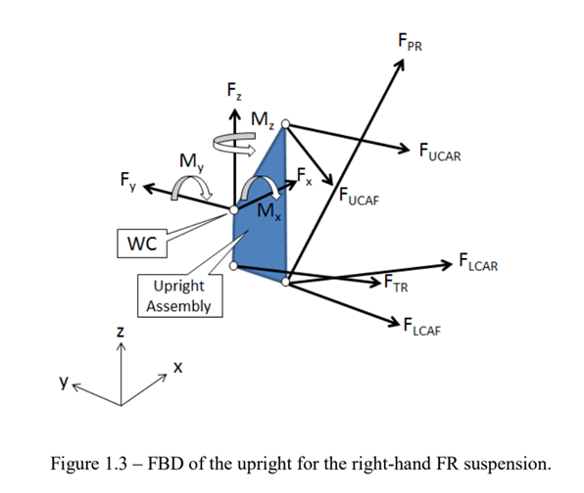
We have a total of 6 arms connected to the upright, Pushrod, Tie rod, Lower control arm front, lower control arm rear, upper control arm front and upper control arm rear as depicted above.
Thus, balancing the forces in the x, y, z directions as well as the moments of the x, y, z directions we obtain 6 linear equations in 6 variables.
$$ΣF_{x}=0= F_{TR}u_{{TR}_{x}}+ F_{LCAF}u_{{LCAF}_{x}}+ F_{LCAR}u_{{LCAR}_{x}}+ F_{UCAF}u_{{UCAF}_{x}}+ F_{UCAR}u_{{UCAR}_{x}}+ F_{PR}u_{{PR}_{x }}+ F_{x}$$
$$ΣF_{y}=0= F_{TR}u_{{TR}_{y}}+ F_{LCAF}u_{{LCAF}_{y}}+ F_{LCAR}u_{{LCAR}_{y}}+ F_{UCAF}u_{{UCAF}_{y}}+ F_{UCAR}u_{{UCAR}_{y}}+ F_{PR}u_{{PR}_{y}}+ F_{y}$$
$$ΣF_{z}=0= F_{TR}u_{{TR}_{z}}+ F_{LCAF}u_{{LCAF}_{z}}+ F_{LCAR}u_{{LCAR}_{z}}+ F_{UCAF}u_{{UCAF}_{z}}+ F_{UCAR}u_{{UCAR}_{z}}+ F_{PR}u_{{PR}_{z}}+ F_{z}$$
$$ΣM_{x}=0= {F_{TR}\left(n_{z}r_{y}- n_{y}r_{z}\right)}_{TR}+{F_{LCAF}\left(n_{z}r_{y}- n_{y}r_{z}\right)}_{LCAF}+{F_{LCAR}\left(n_{z}r_{y}- n_{y}r_{z}\right)}_{LCAR}+{F_{UCAF}\left(n_{z}r_{y}- n_{y}r_{z}\right)}_{UCAF}+{F_{UCAR}\left(n_{z}r_{y}- n_{y}r_{z}\right)}_{UCAR}+{F_{PR}\left(n_{z}r_{y}- n_{y}r_{z}\right)}_{PR}+M_{x}$$

$$ΣM_{y}=0= {F_{TR}(n_{z}r_{x}- n_{x}r_{z})}_{TR}+{F_{LCAF}(n_{z}r_{x}- n_{x}r_{z})}_{LCAF}+{F_{LCAR}(n_{z}r_{x}- n_{x}r_{z})}_{LCAR}+{F_{UCAF}(n_{z}r_{x}- n_{x}r_{z})}_{UCAF}+{F_{UCAR}(n_{z}r_{x}- n_{x}r_{z})}_{UCAR}+{F_{PR}(n_{z}r_{x}- n_{x}r_{z})}_{PR}+M_{y}$$
$$ΣM_{z}=0= {F_{TR}(n_{y}r_{x}- n_{x}r_{y})}_{TR}+{F_{LCAF}(n_{y}r_{x}- n_{x}r_{y})}_{LCAF}+{F_{LCAR}(n_{y}r_{x}- n_{x}r_{y})}_{LCAR}+{F_{UCAF}(n_{y}r_{x}- n_{x}r_{y})}_{UCAF}+{F_{UCAR}(n_{y}r_{x}- n_{x}r_{y})}_{UCAR}+{F_{PR}(n_{y}r_{x}- n_{x}r_{y})}_{PR}+M_{z}$$

To solve this, we use the matrix method.
The basic format would be A {x} = B.
Where, A matrix is a 6x6 matrix. The first three rows are the unit vectors of the force through the arms. The next 3 rows are the moment arms for the forces in the arms. The format is as shown in the figure below.
$$A=[\begin{matrix}u_{{TR}_{x}} & u_{{LCAF}_{x}} & u_{{LCAR}_{x}} & u_{{UCAF}_{x}} & u_{{UCAR}_{x}} & u_{{PR}_{x}} \\ u_{{TR}_{y}} & u_{{LCAF}_{y}} & u_{{LCAR}_{y}} & u_{{UCAF}_{y}} & u_{{UCAR}_{y}} & u_{{PR}_{y}} \\ u_{{TR}_{z}} & u_{{LCAF}_{z}} & u_{{LCAR}_{z}} & u_{{UCAF}_{z}} & u_{{UCAR}_{z}} & u_{{PR}_{z}} \\ {(n_{z}r_{y}-n_{y}r_{z})}_{TR} & {(n_{z}r_{y}-n_{y}r_{z})}_{LCAF} & {(n_{z}r_{y}-n_{y}r_{z})}_{LCAR} & {(n_{z}r_{y}-n_{y}r_{z})}_{UCAF} & {(n_{z}r_{y}-n_{y}r_{z})}_{UCAR} & {(n_{z}r_{y}-n_{y}r_{z})}_{PR} \\ {(n_{z}r_{x}-n_{x}r_{z})}_{TR} & {(n_{z}r_{x}-n_{x}r_{z})}_{LCAF} & {(n_{z}r_{x}-n_{x}r_{z})}_{LCAR} & {(n_{z}r_{x}-n_{x}r_{z})}_{UCAF} & {(n_{z}r_{x}-n_{x}r_{z})}_{UCAR} & {(n_{z}r_{x}-n_{x}r_{z})}_{PR} \\ {(n_{y}r_{x}-n_{x}r_{y})}_{TR} & {(n_{y}r_{x}-n_{x}r_{y})}_{LCAF} & {(n_{y}r_{x}-n_{x}r_{y})}_{LCAR} & {(n_{y}r_{x}-n_{x}r_{y})}_{UCAF} & {(n_{y}r_{x}-n_{x}r_{y})}_{UCAR} & {(n_{y}r_{x}-n_{x}r_{y})}_{PR}\end{matrix}]$$

Matrix {x} is the solution 6x1 matrix. Containing the magnitudes of the forces in the arms.

$$\{x\}=\left[\begin{matrix}F_{TR} \\ F_{LCAF} \\ F_{LCAR} \\ F_{UCAF} \\ F_{UCAR} \\ F_{PR}\end{matrix}\right]$$

Matrix B is of 6 x 1 form and represents the input load cases. The first three rows represent the longitudinal force (Fx), lateral force (Fy), and vertical force (Fz) on the tyre contact patch. The next three rows represent the moments in the x, y, z directions due to these forces about the origin.
$$B=\left[\begin{matrix}F_{x} \\ F_{y} \\ F_{z} \\ M_{x} \\ M_{y} \\ M_{z}\end{matrix}\right]$$

After forming the A and B matrices, we solve them using:
{x} = A⁻¹B

7.4 Results
Upon carrying out the procedure in 7.3 we obtain the following results for matrices A, B, and {x] respectively.

A =
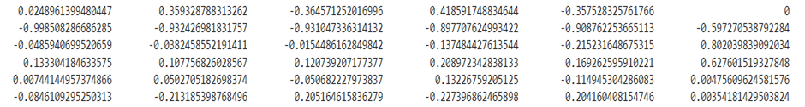

B =
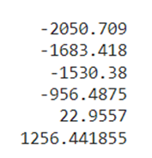

{x} =
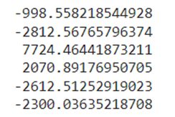

Chapter 4: Results and Discussion

5.1 Introduction

5.2 Conclusion

6. Future Work

Bibliography
There are no sources in the current document.

    - Any text or information should not be logically inconsistent (q@# vchttps://yourlogicalfallacyis.com/).”?>$rtt

